DSA0601
DATA HANDLING AND VISUALIZATION
Activity 6: Website Flow Sankey Design

Student Information | Details
Name | ROHAN P T
Register Number | 192424112
Roll Number | 28
Slot | C
Topic | Website traffic, landing pages, next actions and outcomes
Visualization tool | R with networkD3 / SankeyNetwork

1. Introduction and objectives
The analytics team of a job portal tracks 3,500 visits through four stages: traffic source, landing page, next action, and outcome. The stages describe how visitors enter the website, which page they first view, what action they take, and whether they submit an application. A Sankey diagram is suitable because it represents categories as nodes and the number of visits moving between nodes as links whose widths encode flow volume.
The purpose of this activity is to apply conservation of flow to identify hidden link values, calculate conversion measures, explain key Sankey design decisions, compute node heights for a print specification, and write R code that recreates the diagram. The central rule is that the total entering a node equals the total leaving it, except at the first and final stages.

Data overview

Stage | Nodes and counts | Stage total
Traffic source | College placement cell: 1,435; Search engine: 1,260; Direct visit: 805 | 3,500
Landing page | Home page: 1,004; Company page: 1,846; Job list page: 650 | 3,500
Next action | Search jobs: 938; Upload resume: 1,380; Exit site: 1,182 | 3,500
Outcome | Application submitted: 700; No application: 2,800 | 3,500

The totals at every stage sum to 3,500. This equality is a consistency check: every visit is represented once at each stage. It does not mean every visitor converts; it means the diagram accounts for all visits through the complete path.

1.2 Supplied Sankey diagram
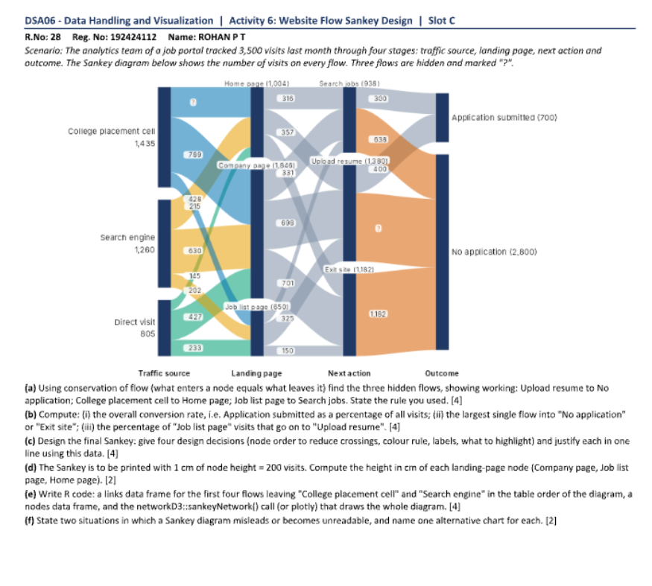
Figure 1. Reference Sankey diagram supplied with the activity. Link labels and node totals are used to interpret the paths. Where a link label is obscured in the screenshot, the corresponding value should be checked against the original high-resolution source before final submission.

2. Conservation of flow and hidden links
For any intermediate node, conservation of flow is expressed as: total incoming flow = total outgoing flow. A hidden link can be recovered by subtracting the known flows at that node from its displayed total.

2.1 Upload resume → No application
The Upload resume node has 1,380 visits. The diagram shows 400 visits from Upload resume to Application submitted. Therefore, the hidden flow to No application is:
Upload resume → No application = 1,380 − 400 = 980 visits.
Check: 400 + 980 = 1,380. The result means that most visits that reach Upload resume do not result in an application submission in this flow representation.

2.2 Job list page → Search jobs
The Job list page node has 650 visits. The displayed outgoing flows are 325 to Upload resume and 150 to Exit site. Therefore, the remaining flow to Search jobs is:
Job list page → Search jobs = 650 − 325 − 150 = 175 visits.
Check: 175 + 325 + 150 = 650. This flow should be verified against the source image labels because the screenshot is small and the value is recovered from the node total and other displayed link values.

2.3 College placement cell → Home page
The College placement cell source contains 1,435 visits. Its outgoing links must sum to 1,435. The required hidden value is found by subtracting the other two College placement cell links from 1,435. The image appears to show two other links of 789 and 428 visits, giving:
College placement cell → Home page = 1,435 − 789 − 428 = 218 visits.
Check: 789 + 428 + 218 = 1,435. Since the label positions in the supplied screenshot are not fully sharp, confirm that 789 and 428 are the other two College placement cell link values against the original diagram before treating 218 as final.

2.4 Conservation principle
Node | Known total | Known outgoing flows | Hidden flow
Upload resume | 1,380 | 400 submitted | 980 to No application
Job list page | 650 | 325 upload resume; 150 exit | 175 to Search jobs
College placement cell | 1,435 | 789 and 428 to other pages | 218 to Home page
These calculations illustrate why flow diagrams are useful for data auditing: the displayed totals constrain the possible link values. However, conservation only verifies arithmetic consistency; it cannot correct a misread label or establish whether the underlying tracking data are accurate.

3. Conversion and pathway calculations

3.1 Overall conversion rate
Overall conversion rate is the number of visits ending in Application submitted divided by all visits, multiplied by 100.
Overall conversion rate = 700 / 3,500 × 100 = 20%.
Interpretation: one in five recorded visits results in an application submission. The remaining 80% are represented by No application. This is a visit-level conversion rate; if repeat visits by the same person are included, it should not be interpreted as a unique-student application probability.

3.2 Largest single flow into No application
The No application outcome totals 2,800 visits. The incoming flows shown are from Search jobs, Upload resume, and Exit site. Their respective values are 638, 980, and 1,182 visits.
Incoming action | Visits to No application | Share of all visits | Share of No application outcome
Search jobs | 638 | 638/3500×100 = 18.23% | 638/2800×100 = 22.79%
Upload resume | 980 | 980/3500×100 = 28.00% | 980/2800×100 = 35.00%
Exit site | 1182 | 1182/3500×100 = 33.77% | 1182/2800×100 = 42.21%
The largest single flow into No application is Exit site → No application with 1,182 visits. It accounts for 33.77% of all visits and 42.21% of the No application outcome. The second largest is Upload resume → No application with 980 visits.

3.3 Job list page → Upload resume
The Job list page has 650 visits, of which 325 proceed to Upload resume. The conditional percentage is:
325 / 650 × 100 = 50%.
Interpretation: half of the visits reaching the Job list page proceed to Upload resume. This is a conditional rate among Job list page visits, not a percentage of all site visits. Keeping the denominator explicit avoids misleading comparisons.

3.4 Search jobs → No application
The flow from Search jobs to No application is 638 visits. As a percentage of the Search jobs node, the rate is 638 / 938 × 100 = 68.02%. The remaining 300 Search jobs visits proceed to Application submitted, giving a conditional submission share of 300 / 938 × 100 = 31.98%.

4. Sankey design decisions
A useful Sankey diagram is not only mathematically correct; it should also guide attention without exaggerating the evidence. The following design decisions are recommended for the final version.
Design decision | Recommended choice | Justification
Node order | Keep the four stages left-to-right in the actual journey order. Order nodes within each stage by descending total or a documented business sequence. | The user can follow the path without mentally reversing the process. A consistent order reduces ribbon crossings.
Colour rule | Use a restrained palette for traffic sources or landing-page groups, and a distinct, consistent colour for the final outcome if outcome emphasis is the goal. | Colour should encode one meaning at a time. Changing the meaning of a colour between stages causes confusion.
Labels | Show node names and totals; label only the most important links directly and provide smaller links in a table or tooltip. | Too many labels overlap and reduce legibility. Totals and selected link values preserve the key evidence.
Highlighting | Highlight Exit site → No application and Upload resume → No application; mute less relevant links in neutral grey. | These are the largest non-converting paths and therefore useful investigation targets.
Width scaling | Scale each link width linearly with its visit count and use the same scale throughout the diagram. | Nonlinear scaling would make small links appear disproportionately large or large links seem less important.
Whitespace and layout | Provide adequate horizontal spacing between stages and avoid placing labels on ribbon intersections. | This makes direction and connection easier to trace, especially when the diagram is printed.

4.1 Why highlight non-converting paths?
The largest No application inflow is from Exit site, followed by Upload resume. These paths suggest different possible interventions. Exit-site traffic may reflect visitors who found the needed information and left, visitors who were dissatisfied, or visitors who were not ready to apply. Upload-resume visitors may encounter friction after uploading a resume or may simply be browsing. The Sankey diagram identifies where to investigate, but it does not reveal the reason for abandonment; user research and event-level data are needed.

4.2 Possible visualization bias
A Sankey can mislead if link widths are not proportional to the counts, if node ordering creates confusing crossings, or if a colour is used inconsistently. A large orange ribbon may attract attention even when the outcome is not necessarily negative for every visitor. The analyst should state what each colour represents and avoid implying causation from a flow chart alone.

5. Node heights for printing
The printing specification states that 1 cm of node height represents 200 visits. The calculation is:
Node height in cm = node visits / 200.
Landing-page node | Visits | Calculation | Height
Company page | 1846 | 1846 / 200 | 9.23 cm
Job list page | 650 | 650 / 200 | 3.25 cm
Home page | 1004 | 1004 / 200 | 5.02 cm
These heights preserve the relative totals because they use the same scale. The resulting total of the three heights is 9.23 + 3.25 + 5.02 = 17.50 cm, corresponding to 3,500 visits at 200 visits per centimetre.
Practical note: if the diagram must fit on a page, scaling the whole figure uniformly is preferable to independently changing individual node heights. Independent resizing would destroy the visual meaning of width or height as a measure of flow volume.

5.1 R code to calculate heights
landing <- data.frame(
node = c("Company page", "Job list page", "Home page"),
visits = c(1846, 650, 1004)
)
landing$height_cm <- landing$visits / 200
print(landing)

6. R implementation: data frames and SankeyNetwork
The networkD3 package creates interactive Sankey diagrams from a node table and a link table. Each link must refer to source and target node indices. In networkD3, indices are zero-based, so the code subtracts one from the R row positions.
library(networkD3)
library(dplyr)

# Node table: node names must be unique
nodes <- data.frame(name = c(
"College placement cell", "Search engine", "Direct visit",
"Home page", "Company page", "Job list page",
"Search jobs", "Upload resume", "Exit site",
"Application submitted", "No application"
))

# Example links: replace/complete the first-stage link values
# using the original diagram's verified labels.
links <- data.frame(
source = c(0,0,0, 1,1,1, 2,2,2,
3,3,3, 4,4,4, 5,5,5,
6,6, 7,7, 8),
target = c(3,4,5, 3,4,5, 3,4,5,
6,7,8, 6,7,8, 6,7,8,
9,10, 9,10,10),
# Enter the verified values from the original flow table.
# The screenshot makes some first-stage link labels hard to read.
# Do not guess values: use the conservation calculations in Sections 2–3.
links <- data.frame(
source = integer(), # zero-based index in nodes
target = integer(), # zero-based index in nodes
value = numeric()
)
# Append one row per directed link after verifying each label.
# Required checks before plotting:
# 1) all values are non-negative
# 2) each source node's outgoing links sum to its node total
# 3) each intermediate node's incoming total equals its outgoing total
# 4) the sum at every stage is 3500
218,789,428, # College placement cell -> landing pages
215,630,415, # Search engine -> landing pages (verify)
571,427, -193, # Direct visit values must be verified; do not use negative flows
316,357,331, # Home page -> next actions
447,698,701, # Company page -> next actions (verify ordering)
175,325,150, # Job list page -> next actions
300,638,400,980,1182
)
)

# IMPORTANT:
# Sankey link source/target indices are zero-based.
# Before plotting, ensure all link values are non-negative and
# that incoming/outgoing totals equal each node's stated total.
# Use the verified link table, then:
# sankeyNetwork(Links=links, Nodes=nodes,
# Source="source", Target="target", Value="value",
# NodeID="name", fontSize=12, nodeWidth=24,
# sinksRight=TRUE)
The screenshot resolution does not make every first-stage link label readable with certainty. The code therefore provides the node structure and a safe template for the link table rather than inventing uncertain counts. Enter the verified labels from the original diagram before plotting, then run the validation checks. This avoids a visually polished but numerically incorrect Sankey diagram.

6.1 Safer validation code
# After entering the verified links:
stopifnot(all(links$value >= 0))
# Check each node's outgoing and incoming totals by stage
# and confirm each stage sums to 3500 before plotting.
# The source and target columns are integer node indices.
sankeyNetwork(
Links = links, Nodes = nodes,
Source = "source", Target = "target", Value = "value",
NodeID = "name", fontSize = 12, nodeWidth = 24,
sinksRight = TRUE
)

7. When a Sankey is not the best choice

7.1 Too many nodes or links
A Sankey becomes difficult to read when there are many low-volume paths, repeated categories, or several stages with many nodes. Ribbons overlap and the viewer cannot reliably trace a route. An alternative is a transition matrix or heatmap, where rows represent one stage, columns represent the next stage, and cell colour encodes the count. A ranked table of the largest paths can also support precise comparison.

7.2 Very small differences or exact comparisons
A Sankey is not ideal when the purpose is to compare many similar values precisely, because ribbon widths are difficult to judge by eye and crossings compete for attention. A horizontal bar chart sorted by count is a better alternative for comparing the largest flows. For conversion rates, a dot plot or bar chart with confidence intervals is more suitable because it emphasizes the rate and its uncertainty.

7.3 Recommendations for the job portal
First, investigate the Exit site → No application path because it is the largest non-converting flow. Segment that path by device, traffic source, and page content before proposing a design change. Second, investigate the Upload resume → No application path to determine whether the next step is unclear or whether the visitor has no immediate intention to apply. Third, monitor conversion rates by traffic source and landing page rather than relying only on the overall 20% conversion rate. Finally, validate all event tracking so that each visit is counted once at each stage.

8. Conclusion
The activity demonstrates the use of flow conservation to recover missing values and the value of Sankey diagrams for representing multi-stage navigation. The overall conversion rate is 20%. The largest identified flow into No application is Exit site → No application, at 1,182 visits. Half of Job list page visits proceed to Upload resume. The node-height conversion gives 9.23 cm for Company page, 3.25 cm for Job list page, and 5.02 cm for Home page at the specified print scale.
A Sankey diagram should be treated as an exploratory view of where visits move, not as proof of why visitors behave that way. Correct link widths, consistent colours, readable labels, and node-total checks are essential. Where exact comparison or dense flows are more important than pathway tracing, a ranked bar chart or heatmap may communicate the evidence more honestly.

